

**Department of Software Engineering**

**Faculty of Computer Science & Information Technology**

**The Superior University, Lahore**

**Name:** MUHAMMAD HAMZA ALI

**Roll No:** SU92-BSAIM-S24-032

**Section:** 3A

**Subject:** ARTIFICIAL INTELLIGENCE(LAB)

**Task No:** Lab-Task 5(Task-1)

**Task-5**

**DFS With Stack**

**1. Introduction:**

The objective of this task is to implement a Depth-First Search (DFS) algorithm using a stack and a tree representation in Python. The DFS approach helps in traversing a graph or tree structure efficiently.

**2. Features:**

* Uses a dictionary to represent the tree structure.
* Employs a recursive approach to traverse the tree.
* Utilizes a visited list to prevent revisiting nodes.
* Implements a stack to track the current DFS path.
* Prints visited nodes and stops when the goal node is found.
* Outputs the final stack of nodes at the end of execution.

**3. Implementation Details:**

The implementation represents a tree using a dictionary and employs a recursive DFS function to search for a goal node.

**4. User Interaction:**

* The recursive DFS approach effectively traverses the tree.
* The current implementation may lead to excessive recursive calls for larger graphs, an iterative approach using an explicit stack could improve performance.
* The function could be enhanced by handling cyclic graphs to prevent infinite loops.
* Adding comments and structured output formatting would improve readability.

**5. Output:**

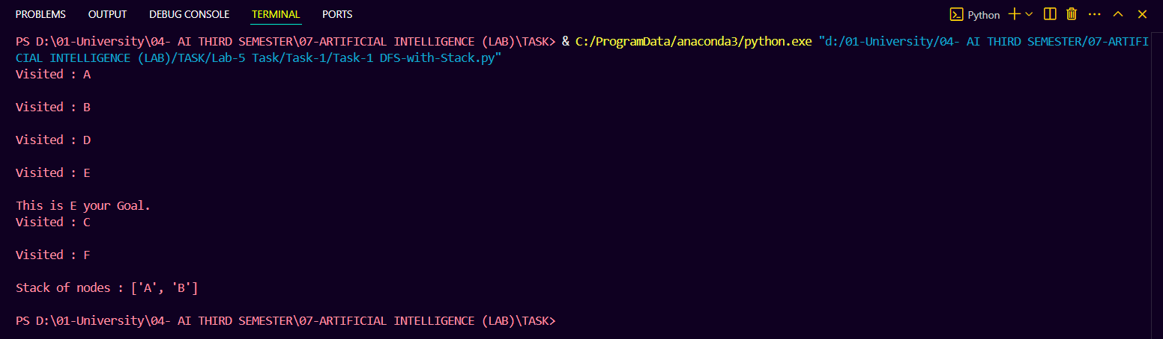

**6. Conclusion:**

This task demonstrates an effective DFS traversal using a stack and recursion. Future improvements may include iterative DFS, cycle detection, and performance optimizations for larger datasets.